Who Should Attend?
Speech-language specialists working in school settings as well as child study team members, special educators and classroom teachers will benefit from this timely and informative workshop.

Special Requests
Please submit any requests for accommodations for special needs in
writing with your registration. Thank you!

Refund Policy
100% is refunded if you cannot attend the seminar providing WCSHLA notified in writing at least one week prior to the seminar.

Relevant Financial Disclosure:
Anthony D. Koustsoftas will be receiving an honorarium and travel support from WCSHLA for his presentation. He is also an employee of Seton Hall University and will be referencing his place of employment during his presentation.
Relevant Non-Financial Disclosures:
Anthony D. Koustsoftas has no relevant non-financial relationships to disclose.

Schedule
8:30 Registration/Continental Breakfast
9:00-9:15 Introduction & Overview
9:15-9:45 Guiding Principles of Intervention
9:45-10:45 Going Meta: Defining Meta-
cognition & Metalinguistics
10:45-11:15 Inference Making Strategies
11:15-12:00 Hands on Activities for
Inference Making when Reading
12:00-12:45 Lunch
12:45-1:00 WCSHLA Business Meeting
1:00- 1:45 Strategies for Supporting
Children’s Writing for a Variety Audiences
& Purposes
1:45-2:45 Metacognitive & Metalinguistic
Strategies for Targeting Phonological,
Semantic & Syntactical Levels of Language
2:45- 3:00 Discussion & Conclusion

WCSLHA OFFICERS
President: Donna Colaco
Phone: (973) 945-4782
E-Mail: spltdc@gmail.com
Vice-President: Melissa Eldred
Phone: (862) 354-0447
E-Mail: meldredslp@yahoo.com
Treasurer: Dina Kozlowski
Phone: (908)-310-7114
E-Mail: dkozlowski@belvideresd.org
Corresponding Secretary: Renee De Luca
Phone: (973)-691-9171
E-Mail: rdlspeech@optonline.net
Recording Secretary: Rosemarie Perretta
Phone: (908) 763-0303
E-Mail: wcslha@gmail.com

Warren County Speech
Language Hearing
Association

Presents:
Going Meta! Cognitive and Linguistic Strategies for School-Based Speech Language Pathologists

By
Anthony D. Koutsoftas

May 18, 2020

Quality Inn 1925 Route 57 Hackettstown, NJ 07840
(908)-813-8500
Please use Google directions

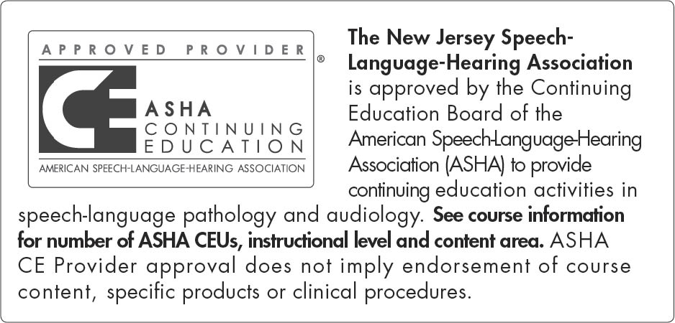

This course is offered for 0.5 ASHA CEUs
(intermediate level, professional area)

About Our Speaker
Anthony D. Koutsoftas is an Associate Professor in the Department of Speech Language Pathology in the School of Health and Medical Sciences at Seton Hall University, Nutley, NJ. He received his bachelor’s degree from New York University, master’s degree from Teachers College, Columbia University, and PhD from Arizona State University. Anthony teaches undergraduate, graduate, and doctoral courses related to language and literacy in school age populations as well as research methods courses. Anthony’s research interests include the development of reading, oral language, and writing abilities in typically developing children and children at risk for academic failure including children with Language-Based Learning Disabilities and Developmental Language Disorders. Anthony is currently collaborating with occupational therapists to better understand how an interprofessional approach to writing instruction can benefit students with language-based learning disabilities. Anthony runs a private practice focused on treatment and support for language and literacy needs for school age children and adults.

Workshop Description
The purpose of this workshop is to provide speech-language pathologists (SLPs) instruction and support including meta-cognitive and meta-linguistic strategies as part of speech language interventions in school settings. This workshop will focus on defining and describing meta-cognitive and
meta-linguistic strategies for children with speech and language disorders, and then provide demonstrations as to how these can be included as part of speech language therapy. Particular emphasis will be placed on including meta-cognitive and meta-linguistic strategies to support reading and writing for children receiving speech language services. For reading: meta- cognitive and meta-linguistic strategies will be centered around making inferences from the text. For writing: meta-cognitive and meta- linguistic strategies will be centered around writing for a variety of audiences and purposes. Additionally, meta- cognitive and meta-linguistic approaches for targeting language at the phonological, semantic, and syntactic levels will be demonstrated for participants.

Learner Outcomes
After attending this workshop, participants will be able to:
1. Define and explain what meta-cognitive and meta-linguistic strategies are and how these can be included as part of speech & language interventions for children on school provider’s caseloads.
2. Differentiate types of inferences that children can make when reading texts and how to target these as part of meta-linguistic interventions in school settings.
3. Explain at least one meta-cognitive and meta-linguistic strategy for language interventions at the phonological, semantic, and syntactic levels.

Handouts will not be provided. Available on website 1 week prior to workshop at
www.wcslha.org

Registration Form

Name:
Address:
Telephone:
Employer:
E-mail:

FEES:
$ 60.00 WCSLHA Members
$ 90.00 Non-Members
$ 40.00 Full-Time Students
Make check payable to WCSLHA
Please send registration even if you are waiting for a PO from your district:
____I am a member of WCSLHA and am
enclosing $ 60.00 for the workshop.
____I am a guest and am enclosing $ 90.00.
____I am a full-time speech pathology
student and am enclosing $ 40.00.

**Workshop Fee includes breakfast and lunch.**
Mail registration by May 11, 2020 to:
WCSLHA C/O Dina Kozlowski, 31 Parker’s Point Blvd, Forked River NJ 08731
Please Register Early

